Updated Design:

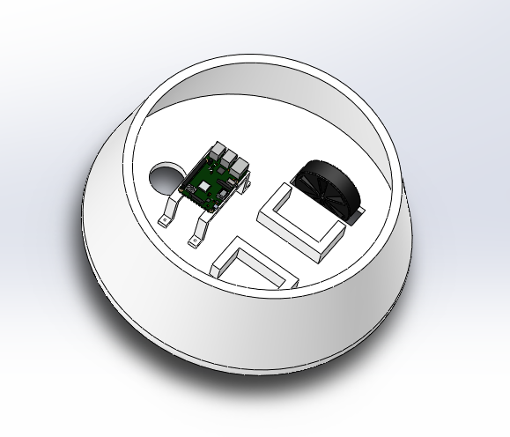Bottom section with the drive train. Not finished but used to start getting weight calculations for power.

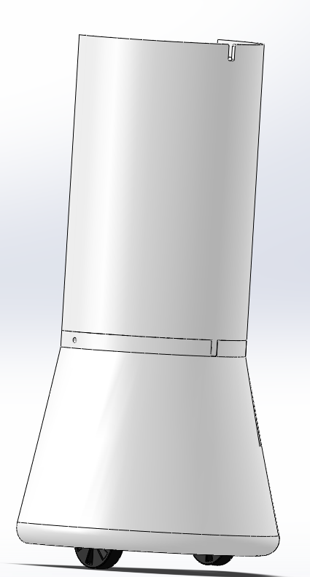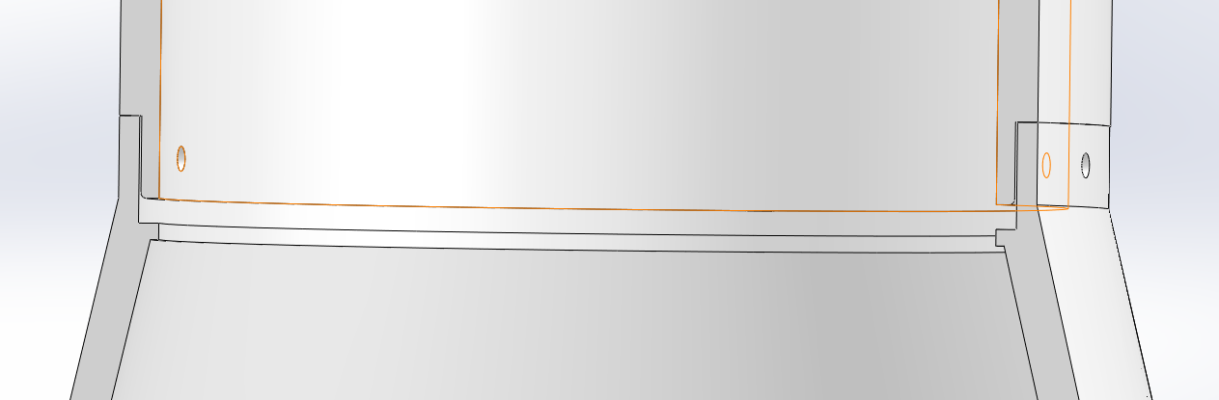

Interlocking design so that the mid-section fits onto the base and can be screwed together. Features a slot so that it is always placed in the same orientation.

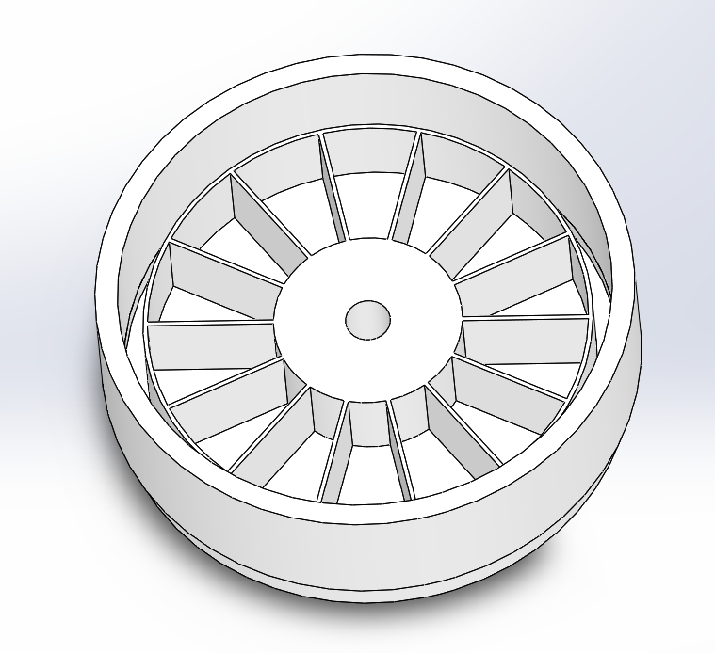

This is the top section where the medicine will be stored in the robot. The inner storage compartment can be switched with different designs of containers in order to suit the needs of that individual patient.

The goal is to create an indexing mechanism (think Geneva mechanism) that will be on a timer. It will rotate the container the desired amount of times a day in order to only show the patient the exact medicine compartment that they will need for that time.

**Mass properties of Final Assembly**

Configuration: Default

Coordinate system: -- default --

Mass = 32.40 pounds

Volume = 879.35 cubic inches

Surface area = 4202.39 square inches

Center of mass: ( inches )

X = 5.66

Y = 20.18

Z = 21.27

Principal axes of inertia and principal moments of inertia: ( pounds * square inches )

Taken at the center of mass.

Ix = ( 0.00, 1.00, 0.00) Px = 1182.58

Iy = (-1.00, 0.00, -0.01) Py = 4888.38

Iz = (-0.01, 0.00, 1.00) Pz = 4894.79

Moments of inertia: ( pounds * square inches )

Taken at the center of mass and aligned with the output coordinate system.

Lxx = 4888.38 Lxy = 0.00 Lxz = 0.09

Lyx = 0.00 Lyy = 1182.65 Lyz = -17.10

Lzx = 0.09 Lzy = -17.10 Lzz = 4894.71

Moments of inertia: ( pounds * square inches )

Taken at the output coordinate system.

Ixx = 32737.11 Ixy = 3698.54 Ixz = 3898.46

Iyx = 3698.54 Iyy = 16875.95 Iyz = 13888.00

Izx = 3898.46 Izy = 13888.00 Izz = 19123.94

These are the mass properties of the design from Solidworks so far. This is the information we will use to start a rough outline for our power requirements and update it as we know more information.

Complete

* Desktop User Interface
  + Request Robot Now Button
  + Schedule Delivery Time Option
* Database connection
  + Scheduled Delivery Times are populated in database

In Progress

* Mobile Interface
  + Detecting mobile devices